1. **Membership Operation**



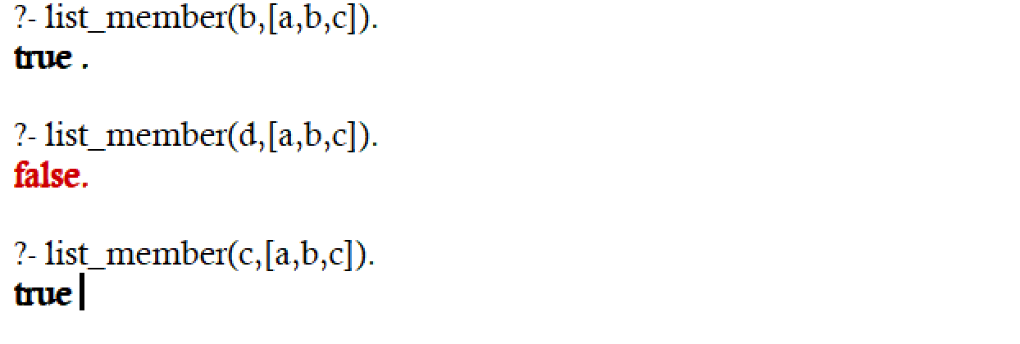

1. **Length Calculation**



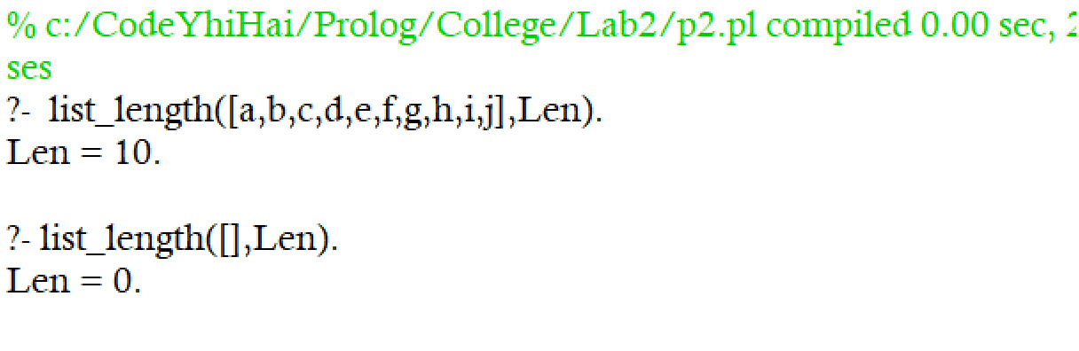

1. **Concatenation**

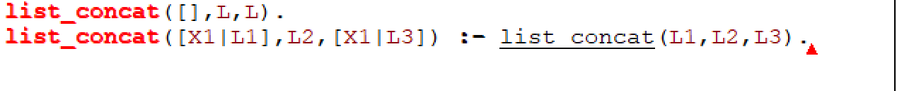

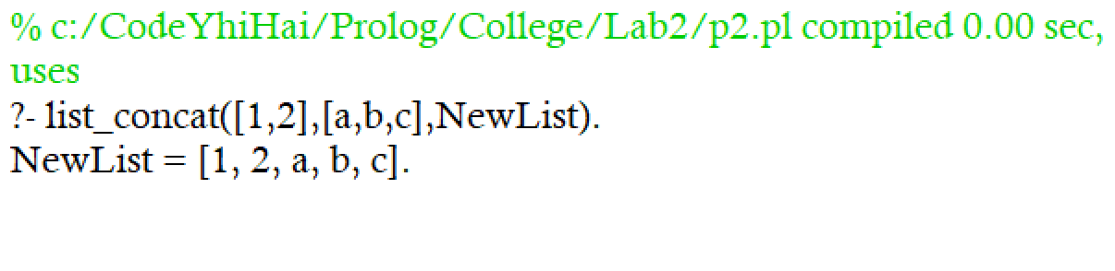

1. **Delete From List**



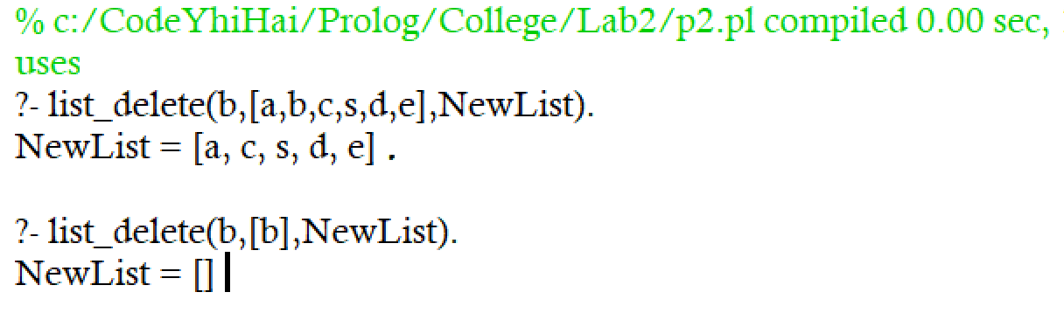

1. **Append Into List**

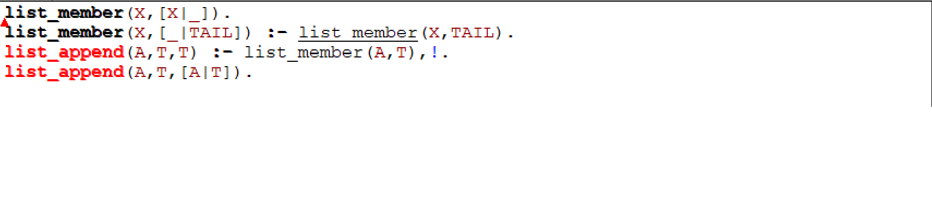

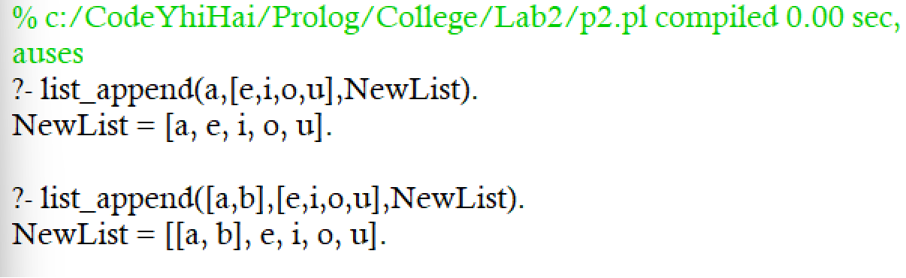

1. **Insert Into List**



